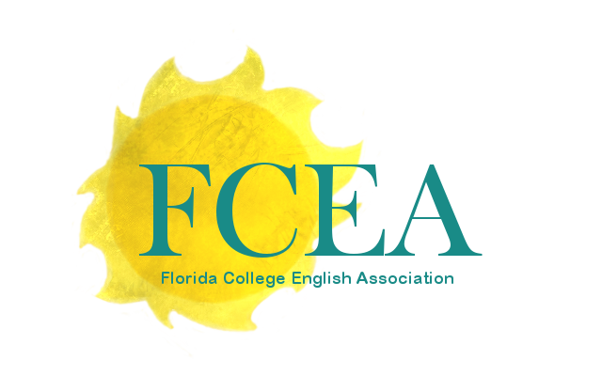
The Florida Scholarly Review

Nowhere is the changing landscape of higher education more evident than in Florida. From changing student demographics and enrollment to discussions surrounding academic freedom, our institutions of higher education are at the forefront of many political and philosophical conversations. Oftentimes, the intellectual and creative work of the faculty, staff, and independent scholars that support these institutions continues to challenge and further these conversations. However, there is more fluidity in Florida than merely the political situation: our natural environment is in a state of flux as our population is growing at an exponential rate. While the impacts of climate change are becoming evident in myriad ways, tract housing communities spring up seemingly overnight, appearing to sprout overnight from the Florida hammock. Vulnerable populations, from LGBTQ individuals to trans youth to native species of flora and fauna, become more vulnerable with each passing legislative session or zoning permit granted. The Buddha’s reminder that “Nothing is permanent, except change” can be felt in every corner of Florida life.

Taking our cue from the 2023 theme for the Florida College English Association’s annual conference, Changing Landscapes, The Florida Scholarly Review seeks submissions of scholarly, creative, or pedagogical essays of 2500-5000 words that reflect the contemporary moment. Fields of study may include but are not limited to literary studies, digital humanities, film studies, sociology, cultural studies, history, popular culture, and pedagogy. While we encourage submissions that are centered on the rich historical, cultural, and literary culture of Florida, submission do not have to encompass Florida. Potential questions to address include:

- What does it mean to teach in our country (or individual state) today?
- How are educators responding to the changing landscape in the face of climate change?
- What does academic freedom mean today?
- What do our students expect of higher education today?
- How have teachers from previous ages adapted to face similar situations?
- What can the humanities teach us about the contemporary moment?

Papers should be 10-20 pages in length, submitted in MS Word and formatting according to MLA 8th edition. Please include a 250-word abstract and your current contact information, including an email address you check frequently. Please do not send previously submitted or published work.

Additionally, we are seeking submissions of art for the inside of the journal and also cover art.

Deadline for Abstract and Art Submissions: Monday, January 15, 2024.
Acceptance Decision: Friday, March 15, 2024
Final Essay Due: May 15, 2024
Please send to: FLScholarlyRev@gmail.com

